#### AEC SIMULATION ASSIGNMENT

USN:

DIV:

Roll. No:

1. **Unbiased Parallel Positive Clipper Circuit**:

* Circuit:

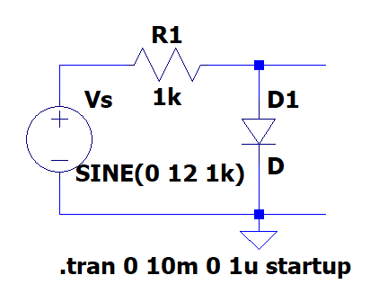

* Input Waveform:

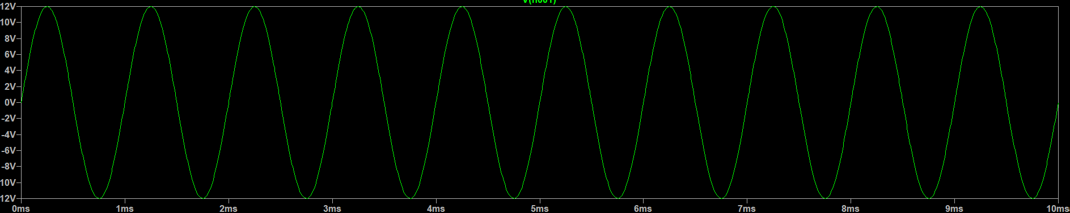

* Input -Output Waveform:

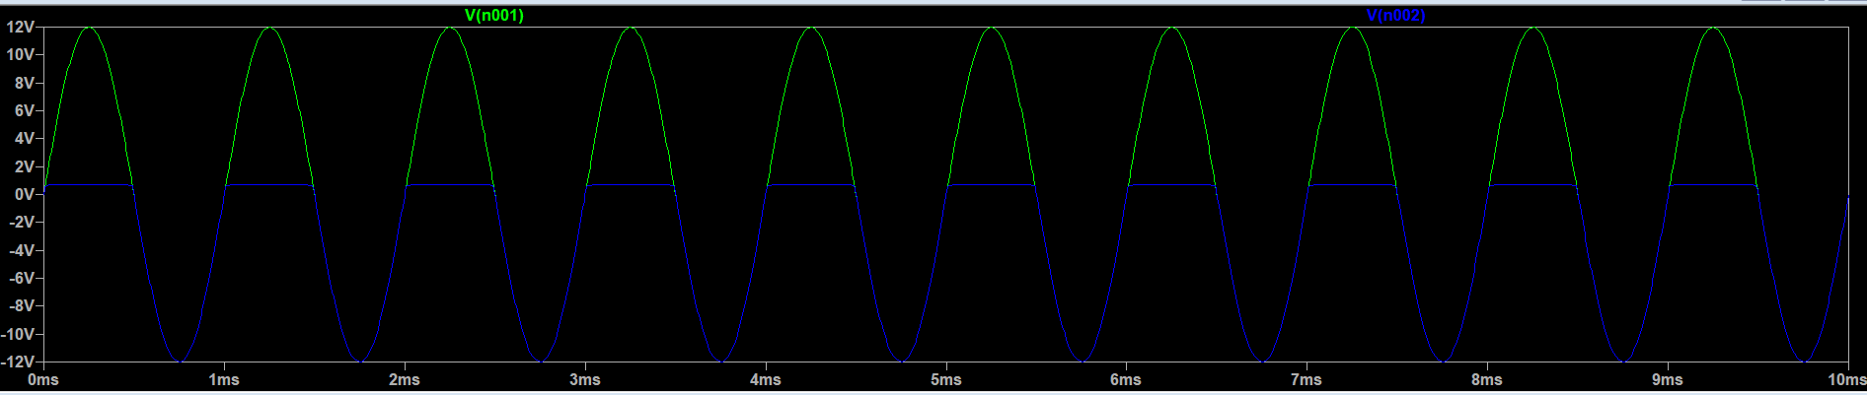

* Table Of Observations:

|  |  |  |  |  |
| --- | --- | --- | --- | --- |
| **SI.NO** | **Frequency in Hz** | **Vin pp in Volts** | **Vo pp**  **in Volts** | **Clipped off portion**  **= Vin pp – Vo pp** |
|  | **1k** | **24** | **12.6** | **11.4** |

1. **Unbiased Parallel Negative Clipper Circuit:**

* Circuit:

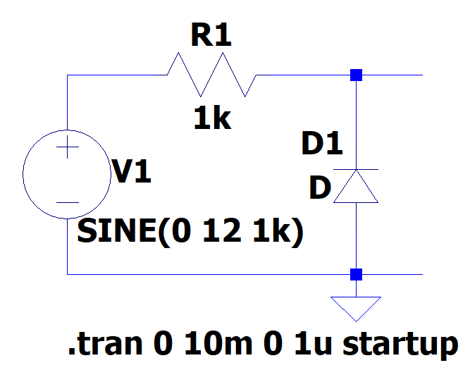

* Input Waveform:

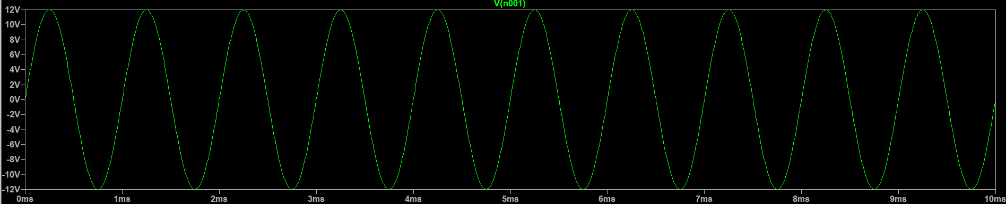

* Input-Output Waveform:

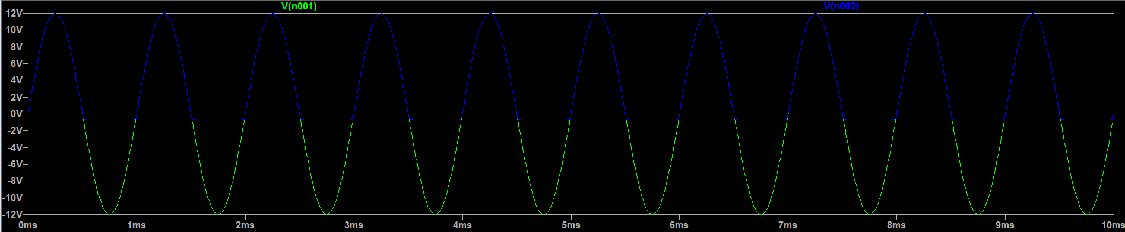

* Table Of Observations:

|  |  |  |  |  |
| --- | --- | --- | --- | --- |
| **SI.NO** | **Frequency in Hz** | **Vin pp in Volts** | **Vo pp**  **in Volts** | **Clipped off portion**  **= Vin pp – Vo pp** |
|  | **1k** | **24** | **12.6** | **11.4** |

1. **Unbiased Parallel Combinational Clipper Circuit:**

* Circuit:

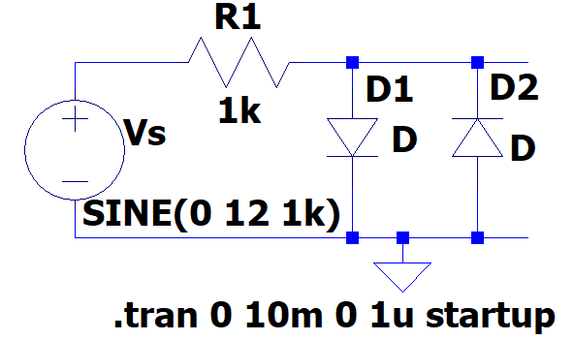

* Input Waveform:

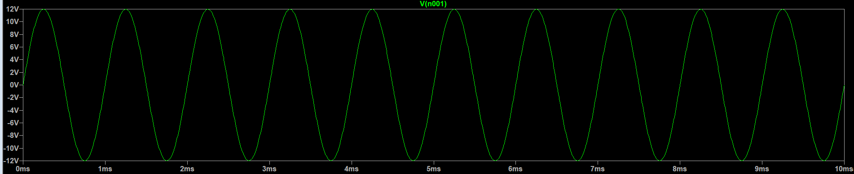

* Input-Output Waveform:

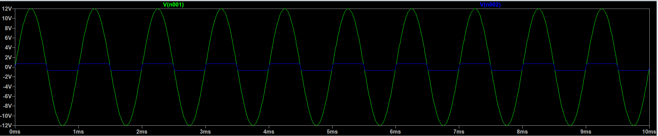

* Table Of Observations:

|  |  |  |  |  |
| --- | --- | --- | --- | --- |
| **SI.NO** | **Frequency in Hz** | **Vin pp in Volts** | **Vo pp**  **in Volts** | **Clipped off portion**  **= Vin pp – Vo pp** |
|  | **1k** | **24** | **1.2** | **22.8** |

1. **Unbiased Series Positive Clipper Circuit:**

* Circuit:

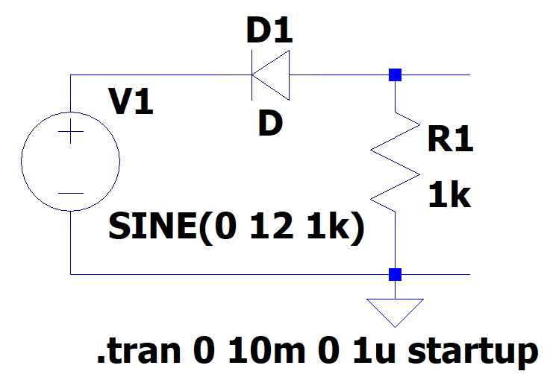

* Input Waveform:

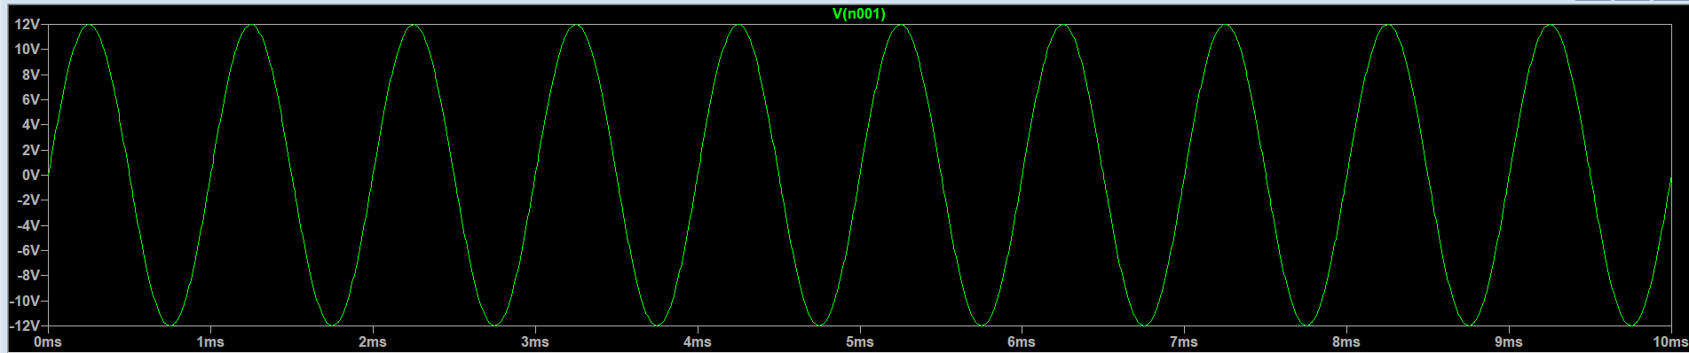

* Input-Output Waveform:

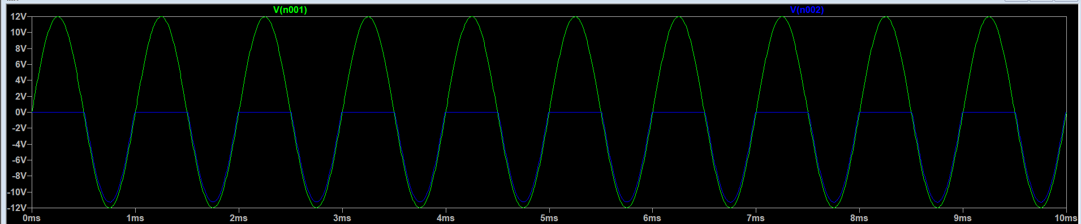

* Table Of Observations:

|  |  |  |  |  |
| --- | --- | --- | --- | --- |
| **SI.NO** | **Frequency in Hz** | **Vin pp in Volts** | **Vo pp**  **in Volts** | **Clipped off portion**  **= Vin pp – Vo pp** |
|  | **1k** | **24** | **11.2** | **12.8** |

1. **Unbiased Series Negative Clipper Circuit:**

* Circuit:

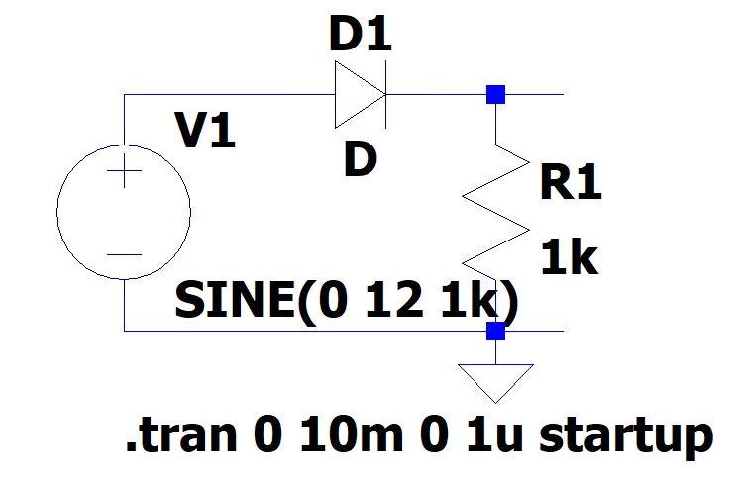

* Input Waveform:

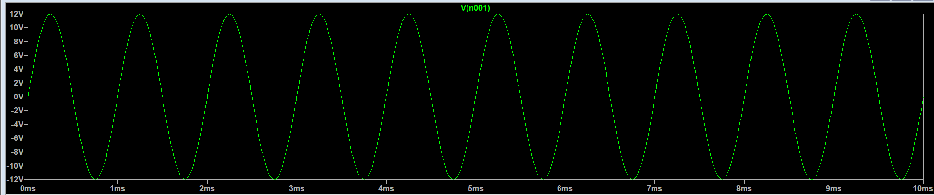

* Input-Output Waveform:

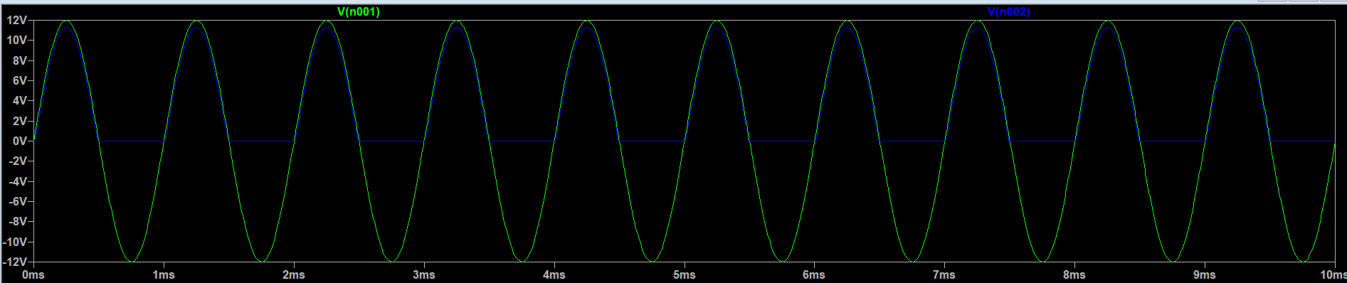

* Table Of Observations:

|  |  |  |  |  |
| --- | --- | --- | --- | --- |
| **SI.NO** | **Frequency in Hz** | **Vin pp in Volts** | **Vo pp**  **in Volts** | **Clipped off portion**  **= Vin pp – Vo pp** |
|  | **1k** | **24** | **11.2** | **12.8** |

1. **Biased Parallel Positive Clipper Circuit With Positive Reference Voltage:**

* Circuit:

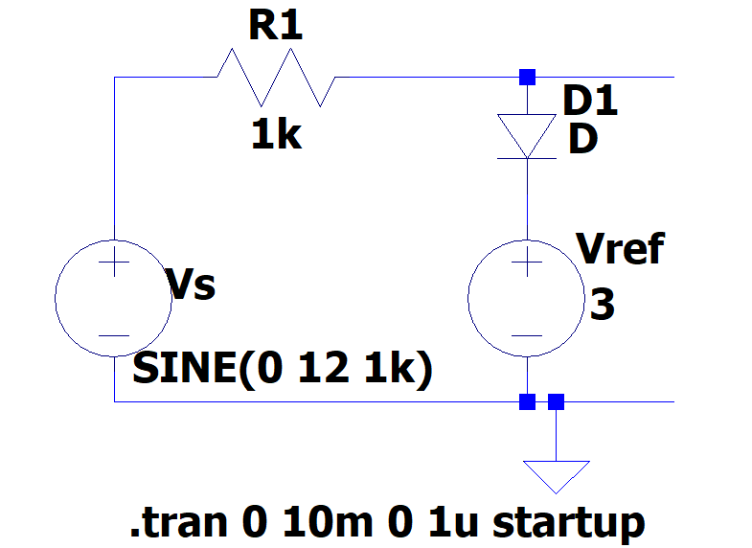

* Input Waveform:



* Input-Output Waveform:

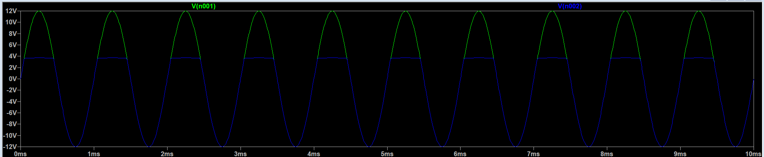

* Table Of Observations:

|  |  |  |  |  |  |
| --- | --- | --- | --- | --- | --- |
| **SI.NO** | **Vref= VR in Volts** | **Frequency in Hz** | **Vin pp in Volts** | **Vo pp**  **in Volts** | **Clipped off portion**  **= Vin pp – Vo pp** |
|  | **1** | **1k** | **24** | **13.7** | **10.3** |
|  | **2** | **1k** | **24** | **14.7** | **9.3** |
|  | **3** | **1k** | **24** | **15.6** | **8.4** |
|  | **4** | **1k** | **24** | **16.7** | **7.3** |
|  | **5** | **1k** | **24** | **17.7** | **6.3** |
|  | **6** | **1k** | **24** | **18.7** | **5.3** |
|  | **7** | **1k** | **24** | **19.7** | **4.3** |
|  | **8** | **1k** | **24** | **20.7** | **3.3** |

1. **Biased Parallel Positive Clipper Circuit With Negative Reference Voltage:**

* Circuit:

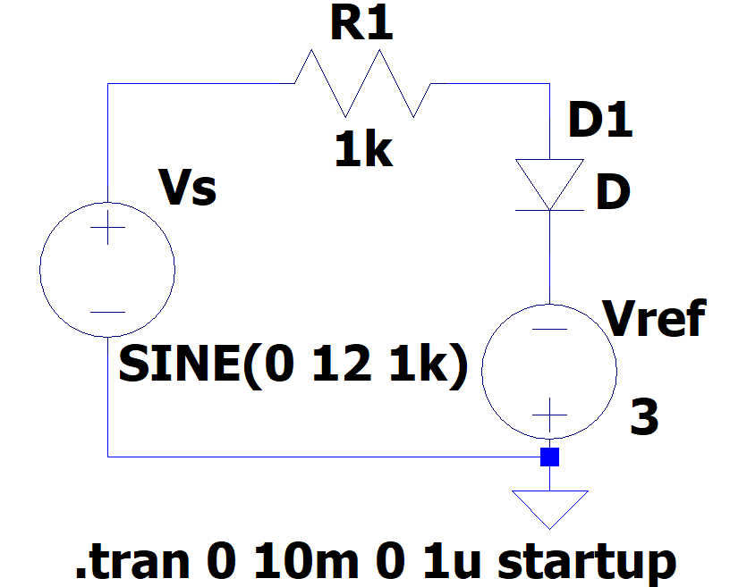

* Input Waveform:



* Input-Output Waveform:

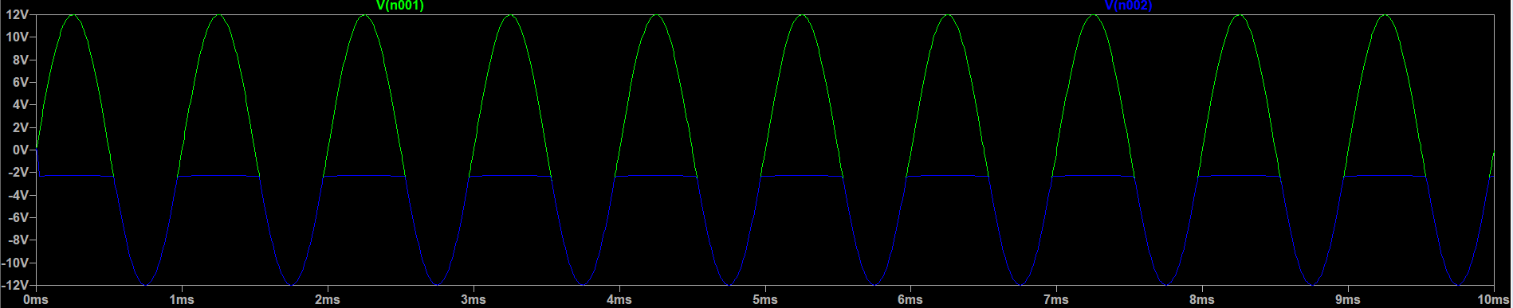

* Table Of observations:

|  |  |  |  |  |  |
| --- | --- | --- | --- | --- | --- |
| **SI.NO** | **Vref= VR in Volts** | **Frequency in Hz** | **Vin pp in Volts** | **Vo pp**  **in Volts** | **Clipped off portion**  **= Vin pp – Vo pp** |
|  | **1** | **1k** | **24** | **11.7** | **12.3** |
|  | **2** | **1k** | **24** | **10.7** | **13.3** |
|  | **3** | **1k** | **24** | **9.7** | **14.3** |
|  | **4** | **1k** | **24** | **8.7** | **15.3** |
|  | **5** | **1k** | **24** | **7.7** | **16.3** |
|  | **6** | **1k** | **24** | **6.7** | **17.3** |
|  | **7** | **1k** | **24** | **5.7** | **18.3** |
|  | **8** | **1k** | **24** | **4.7** | **19.3** |

1. **Biased Parallel Negative Clipper Circuit With Negative Reference Voltage:**

* Circuit:

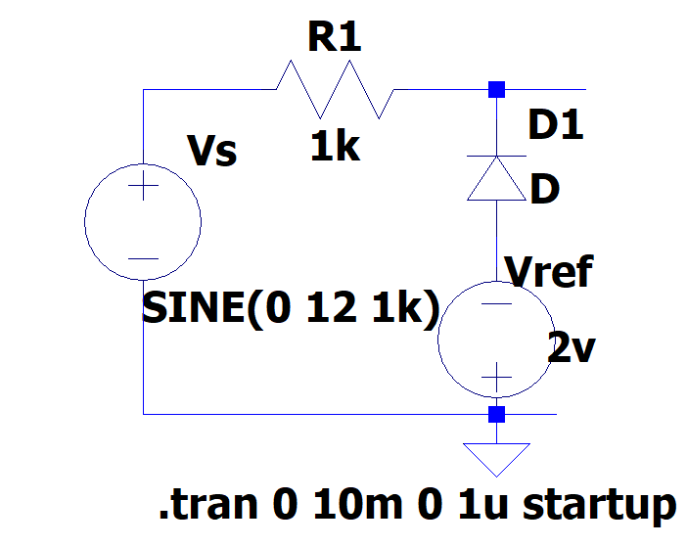

* Input Waveform:



* Input-Output Waveform:

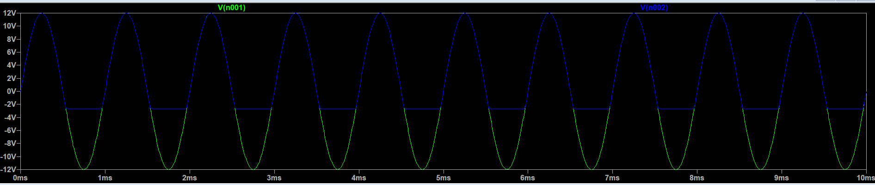

* Table Of Observations:

|  |  |  |  |  |  |
| --- | --- | --- | --- | --- | --- |
| **SI.NO** | **Vref= VR in Volts** | **Frequency in Hz** | **Vin pp in Volts** | **Vo pp**  **in Volts** | **Clipped off portion**  **= Vin pp – Vo pp** |
|  | **1** | **1k** | **24** | **13.6** | **10.4** |
|  | **2** | **1k** | **24** | **14.6** | **9.4** |
|  | **3** | **1k** | **24** | **15.6** | **8.4** |
|  | **4** | **1k** | **24** | **16.6** | **7.4** |
|  | **5** | **1k** | **24** | **17.6** | **6.4** |
|  | **6** | **1k** | **24** | **18.6** | **5.4** |
|  | **7** | **1k** | **24** | **19.6** | **4.4** |
|  | **8** | **1k** | **24** | **20.6** | **3.4** |

1. **Biased Parallel Negative Clipper Circuit With Positive Reference Voltage:**

* Circuit:

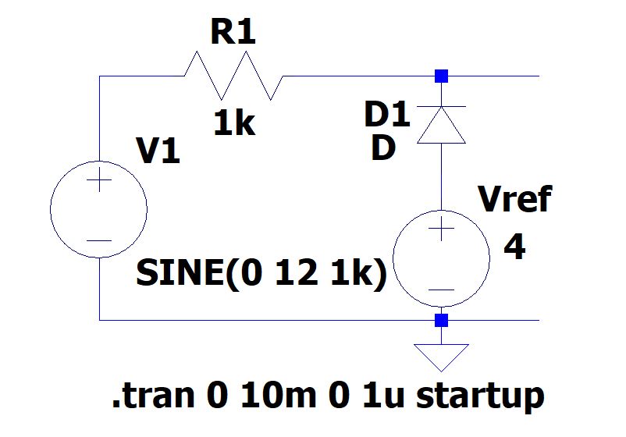

* Input Waveform:



* Input-Output waveform:

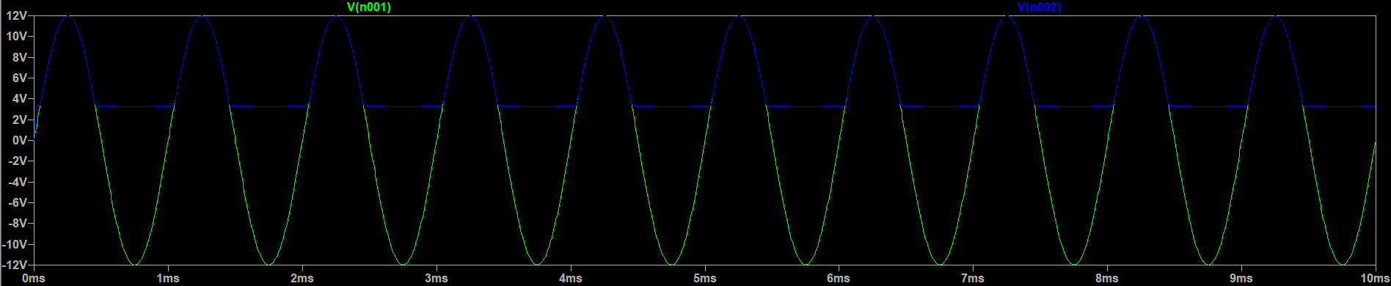

* Table Of Observations:

|  |  |  |  |  |  |
| --- | --- | --- | --- | --- | --- |
| **SI.NO** | **Vref= VR in Volts** | **Frequency in Hz** | **Vin pp in Volts** | **Vo pp**  **in Volts** | **Clipped off portion**  **= Vin pp – Vo pp** |
|  | **1** | **1k** | **24** | **11.6** | **12.4** |
|  | **2** | **1k** | **24** | **10.6** | **13.4** |
|  | **3** | **1k** | **24** | **9.6** | **14.4** |
|  | **4** | **1k** | **24** | **8.6** | **15.4** |
|  | **5** | **1k** | **24** | **7.6** | **16.4** |
|  | **6** | **1k** | **24** | **6.6** | **17.4** |
|  | **7** | **1k** | **24** | **5.6** | **18.4** |
|  | **8** | **1k** | **24** | **4.6** | **19.4** |

1. **Biased Series Positive Clipper Circuit With Positive Reference Voltage:**

* Circuit:

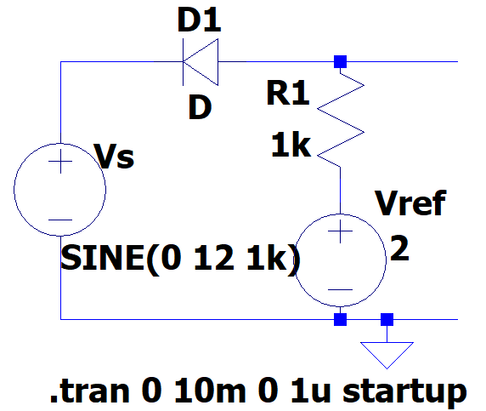

* Input Waveform:



* Input-Output Waveform:

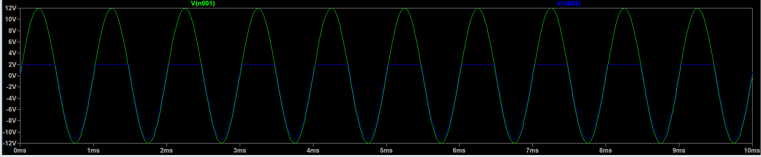

* Table Of Observations:

|  |  |  |  |  |  |
| --- | --- | --- | --- | --- | --- |
| **SI.NO** | **Vref= VR in Volts** | **Frequency in Hz** | **Vin pp in Volts** | **Vo pp**  **in Volts** | **Clipped off portion**  **= Vin pp – Vo pp** |
|  | **1** | **1k** | **24** | **13** | **11** |
|  | **2** | **1k** | **24** | **14** | **10** |
|  | **3** | **1k** | **24** | **15** | **9** |
|  | **4** | **1k** | **24** | **16** | **8** |
|  | **5** | **1k** | **24** | **17** | **7** |
|  | **6** | **1k** | **24** | **18** | **6** |
|  | **7** | **1k** | **24** | **19** | **5** |
|  | **8** | **1k** | **24** | **20** | **4** |

1. **Biased Series Positive Clipper Circuit With Negative Reference Voltage:**

* Circuit:

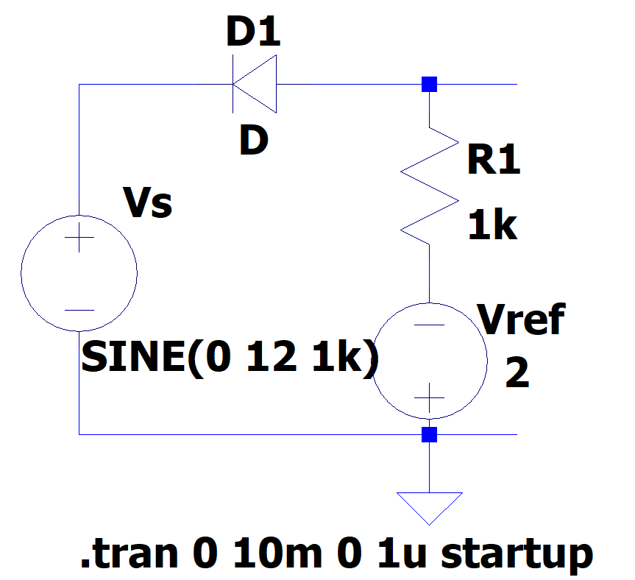

* Input Waveform:



* Input-Output Waveform**:**

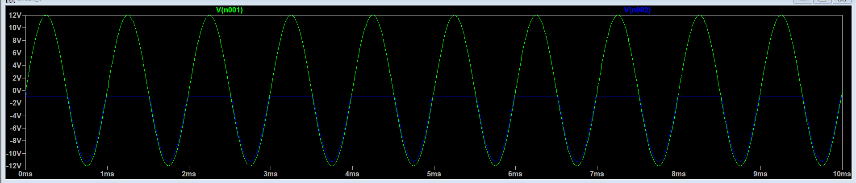

* Table Of Observations:

|  |  |  |  |  |  |
| --- | --- | --- | --- | --- | --- |
| **SI.NO** | **Vref= VR in Volts** | **Frequency in Hz** | **Vin pp in Volts** | **Vo pp**  **in Volts** | **Clipped off portion**  **= Vin pp – Vo pp** |
|  | **1** | **1k** | **24** | **11** | **13** |
|  | **2** | **1k** | **24** | **10** | **14** |
|  | **3** | **1k** | **24** | **9** | **15** |
|  | **4** | **1k** | **24** | **8** | **16** |
|  | **5** | **1k** | **24** | **7** | **17** |
|  | **6** | **1k** | **24** | **6** | **18** |
|  | **7** | **1k** | **24** | **5** | **19** |
|  | **8** | **1k** | **24** | **4** | **20** |

1. **Biased Series Negative Clipper Circuit With Positive Reference Voltage:**

* Circuit:

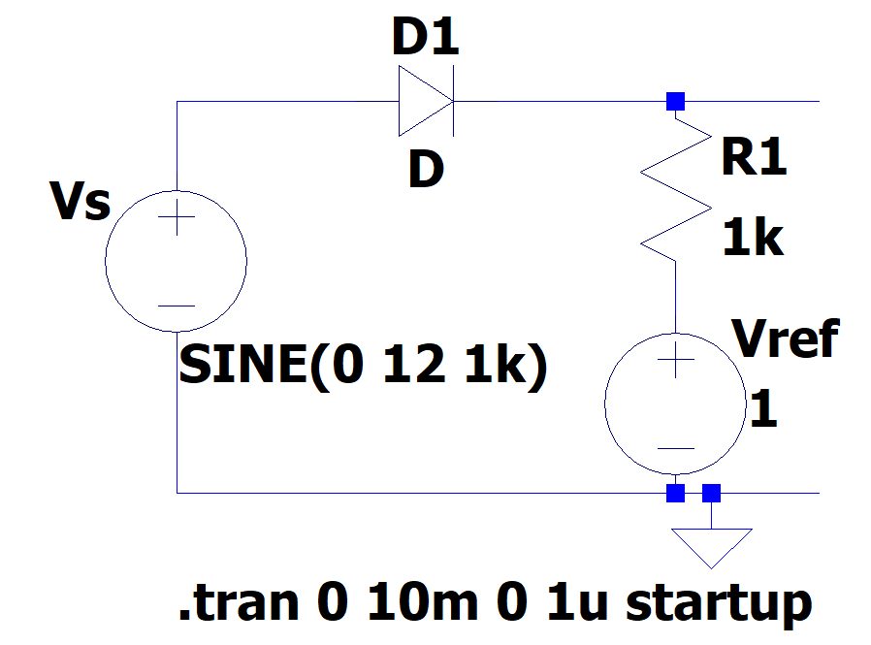

* Input Waveform:



* Input-Output Waveform:

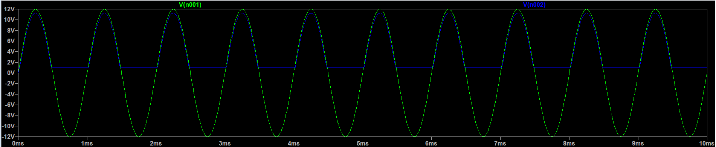

* Table Of Observations:

|  |  |  |  |  |  |
| --- | --- | --- | --- | --- | --- |
| **SI.NO** | **Vref= VR in Volts** | **Frequency in Hz** | **Vin pp in Volts** | **Vo pp**  **in Volts** | **Clipped off portion**  **= Vin pp – Vo pp** |
|  | **1** | **1k** | **24** | **10.2** | **13.8** |
|  | **2** | **1k** | **24** | **9.2** | **14.8** |
|  | **3** | **1k** | **24** | **8.2** | **15.8** |
|  | **4** | **1k** | **24** | **7.2** | **16.8** |
|  | **5** | **1k** | **24** | **6.2** | **17.8** |
|  | **6** | **1k** | **24** | **5.2** | **18.8** |
|  | **7** | **1k** | **24** | **4.2** | **19.8** |
|  | **8** | **1k** | **24** | **3.2** | **20.8** |

1. **Biased Series Negative Clipper Circuit With Negative Reference Voltage:**

* Circuit:

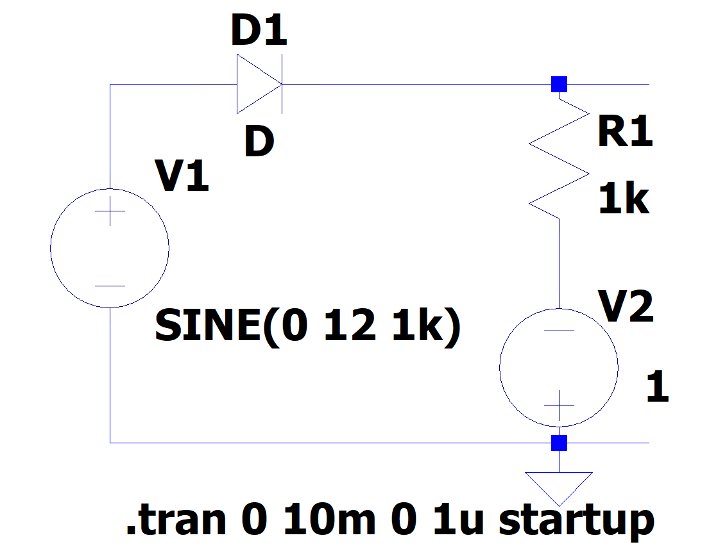

* Input Waveform:



* Input-Output Waveform:

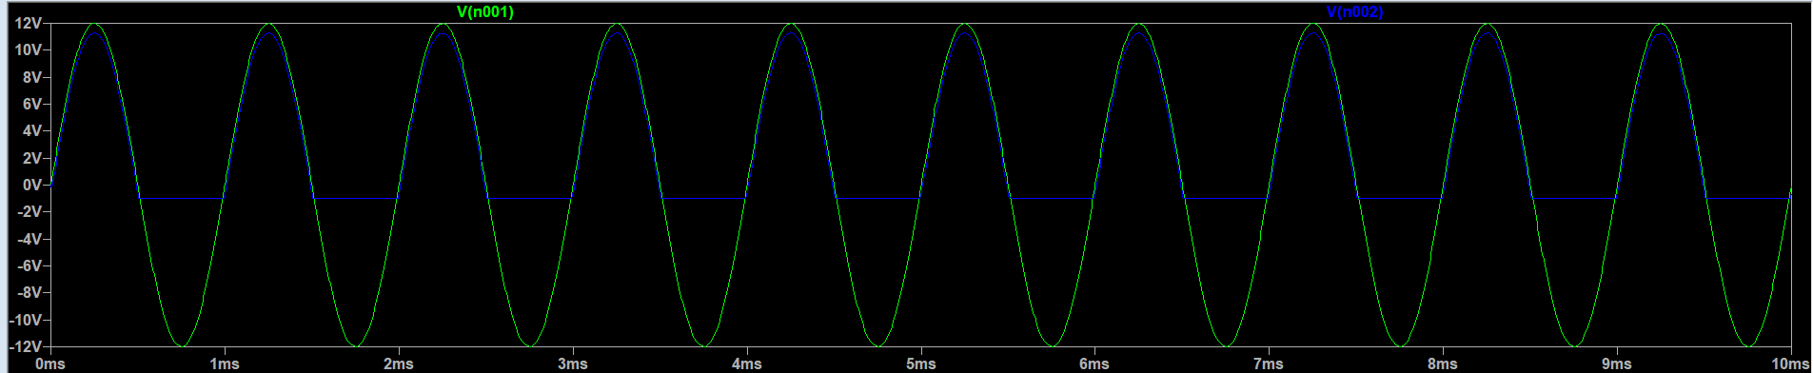

* Table Of Observations:

|  |  |  |  |  |  |
| --- | --- | --- | --- | --- | --- |
| **SI.NO** | **Vref= VR in Volts** | **Frequency in Hz** | **Vin pp in Volts** | **Vo pp**  **in Volts** | **Clipped off portion**  **= Vin pp – Vo pp** |
|  | **1** | **1k** | **24** | **12.2** | **11.8** |
|  | **2** | **1k** | **24** | **13.2** | **10.8** |
|  | **3** | **1k** | **24** | **14.2** | **9.8** |
|  | **4** | **1k** | **24** | **15.2** | **8.8** |
|  | **5** | **1k** | **24** | **16.2** | **7.8** |
|  | **6** | **1k** | **24** | **17.2** | **6.8** |
|  | **7** | **1k** | **24** | **18.2** | **5.8** |
|  | **8** | **1k** | **24** | **19.2** | **4.8** |

1. **Biased Combinational Clipping Circuit:**

* Circuit:

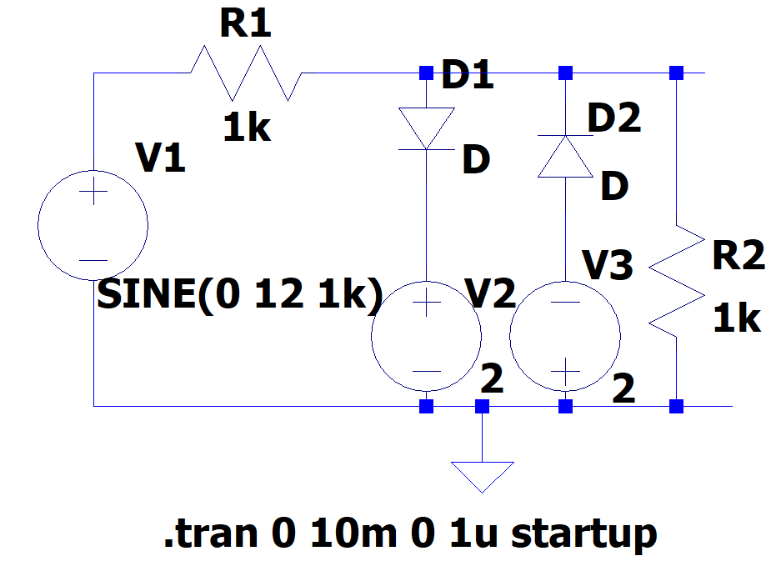

* Input Waveform:



* Input-Output Waveform:

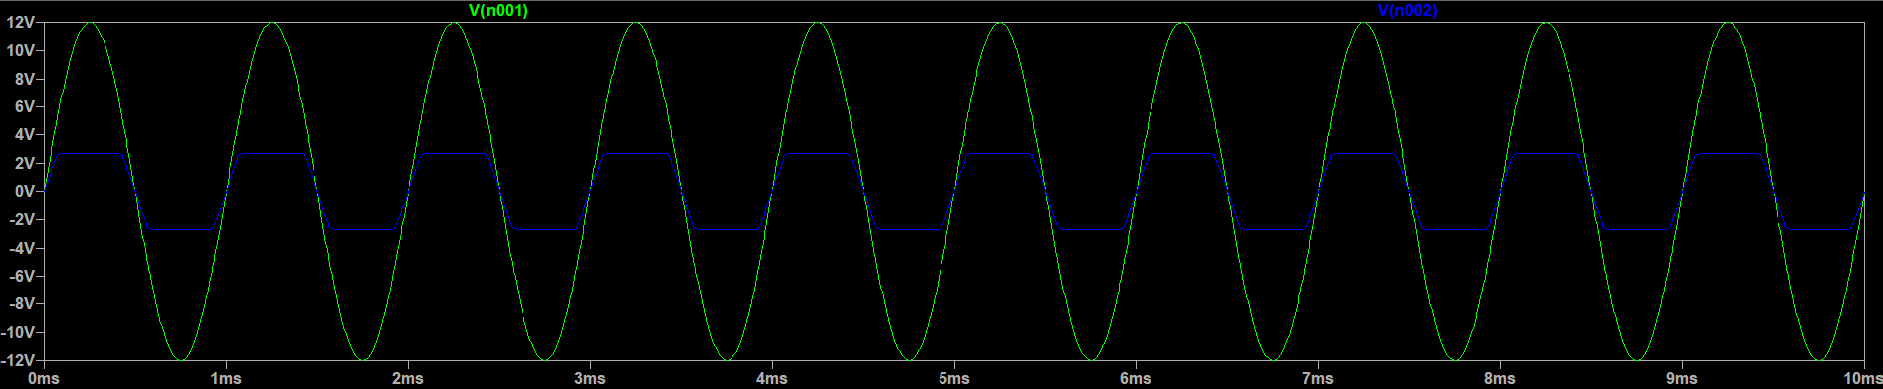

* Table Of Observations:

|  |  |  |  |  |  |
| --- | --- | --- | --- | --- | --- |
| **SI.NO** | **Vref= VR in Volts** | **Frequency in Hz** | **Vin pp in Volts** | **Vo pp**  **in Volts** | **Clipped off portion**  **= Vin pp – Vo pp** |
|  | **1** | **1k** | **24** | **3.4** | **20.6** |
|  | **2** | **1k** | **24** | **5.4** | **18.6** |
|  | **3** | **1k** | **24** | **7.4** | **16.6** |
|  | **4** | **1k** | **24** | **9.4** | **14.6** |
|  | **5** | **1k** | **24** | **11.4** | **12.6** |
|  | **6** | **1k** | **24** | **13.4** | **10.6** |
|  | **7** | **1k** | **24** | **15.4** | **8.6** |
|  | **8** | **1k** | **24** | **17.4** | **6.6** |

1. **Unbiased Positive Clamping Circuit:**

* Circuit:

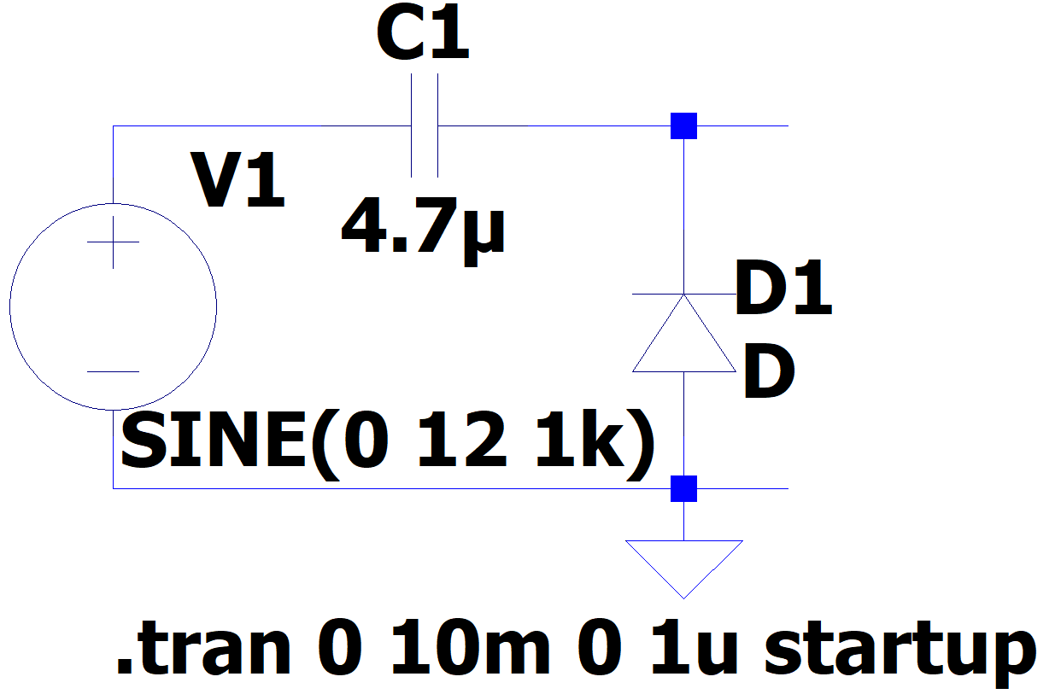

* Input Waveform:



* Input-Output Waveform:

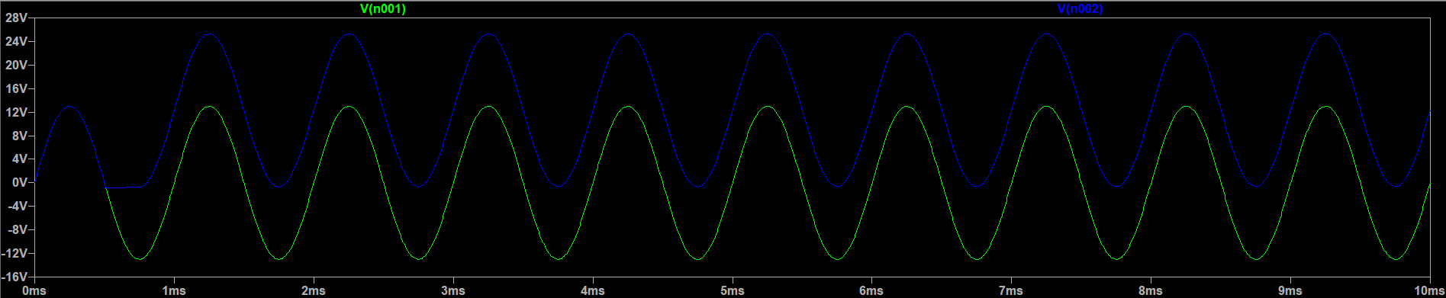

* Table Of Observations:

|  |  |  |  |  |  |
| --- | --- | --- | --- | --- | --- |
| **SI.No** | **I/p voltage** | **I/p frequency** | **Positive peak voltage** | **Negative peak voltage** | **Average or DC voltage of the output** |
|  | **24** | **1k Hz** | **24** | **-0.8** | **11.6** |
|  | **26** | **1k Hz** | **25.2** | **-0.8** | **12.2** |

1. **Unbiased Negative Clamping Circuit:**

* Circuit:

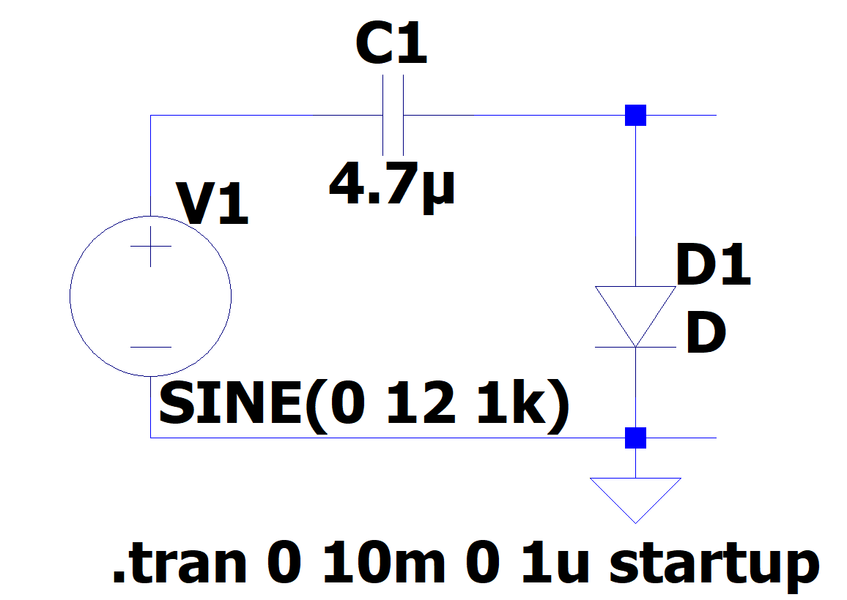

* Input Waveform:



* Input-Output Waveform:

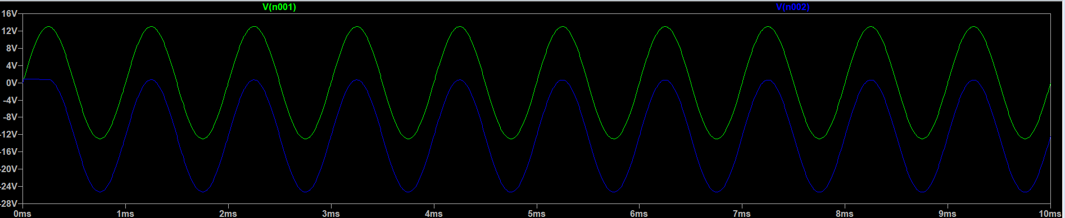

* Table Of Observations:

|  |  |  |  |  |  |
| --- | --- | --- | --- | --- | --- |
| **SI.No** | **I/p voltage** | **I/p frequency** | **Positive peak voltage** | **Negative peak voltage** | **Average or DC voltage of the output** |
|  | **24** | **1k Hz** | **0.8** | **-24** | **-11.6** |
|  | **26** | **1k Hz** | **0.8** | **-25.2** | **-12.2** |

1. **Biased Positive Clamping Circuit With Positive Reference Voltage:**

* Circuit:

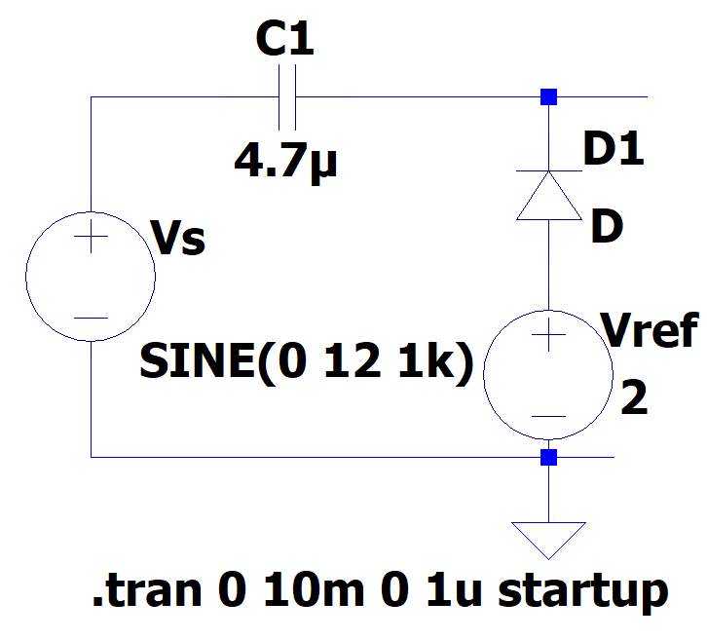

* Input Waveform:



* Input-Output Waveform:

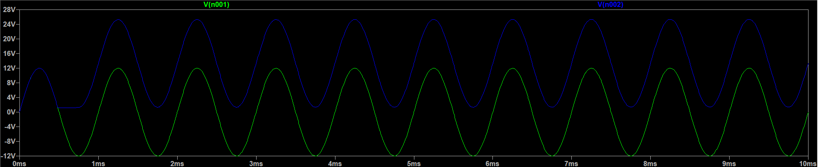

* Table Of Observations:

|  |  |  |  |  |  |  |
| --- | --- | --- | --- | --- | --- | --- |
| **SI.No** | **I/p voltage** | **Reference voltage VR in volts** | **I/p frequency** | **Positive peak voltage** | **Negative peak voltage** | **Average or DC voltage of the output** |
|  | **24** | **1** | **1k Hz** | **24.3** | **0.2** | **12.2** |
|  | **24** | **2** | **1k Hz** | **25.2** | **1.2** | **13.2** |
|  | **24** | **3** | **1k Hz** | **26.2** | **2.2** | **14.2** |
|  | **24** | **4** | **1k Hz** | **27.2** | **3.2** | **15.2** |
|  | **24** | **5** | **1k Hz** | **28.2** | **4.2** | **16.2** |
|  | **24** | **6** | **1k Hz** | **29.3** | **5.2** | **17.25** |
|  | **24** | **7** | **1k Hz** | **30.3** | **6.2** | **18.2** |
|  | **24** | **8** | **1k Hz** | **31.3** | **7.2** | **19.25** |

1. **Biased Positive Clamping Circuit With Negative Reference Voltage:**

* Circuit:

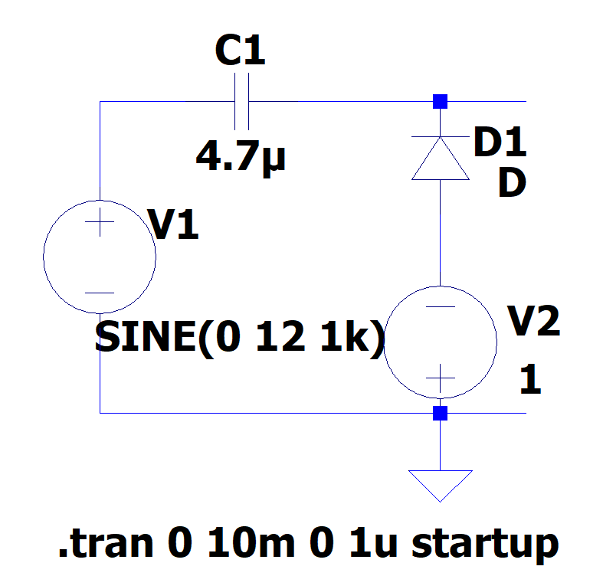

* Input Waveform:



* Input-Output Waveform:

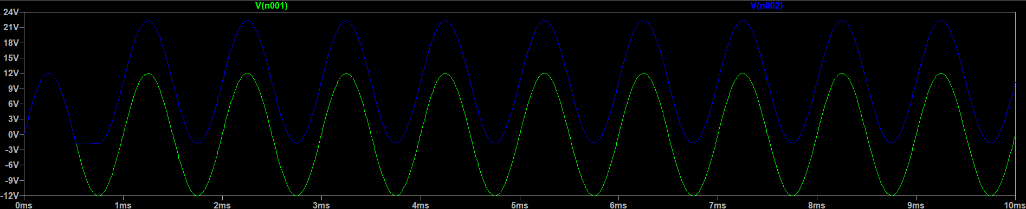

* Table Of Observations:

|  |  |  |  |  |  |  |
| --- | --- | --- | --- | --- | --- | --- |
| **SI.No** | **I/p voltage** | **Reference voltage VR in volts** | **I/p frequency** | **Positive peak voltage** | **Negative peak voltage** | **Average or DC voltage of the output** |
|  | **24** | **1** | **1k Hz** | **22.2** | **-1.8** | **10.2** |
|  | **24** | **2** | **1k Hz** | **21.2** | **-2.8** | **9.2** |
|  | **24** | **3** | **1k Hz** | **20.2** | **-3.8** | **8.2** |
|  | **24** | **4** | **1k Hz** | **19.2** | **-4.8** | **7.2** |
|  | **24** | **5** | **1k Hz** | **18.2** | **-5.7** | **6.25** |
|  | **24** | **6** | **1k Hz** | **17.2** | **-6.7** | **5.25** |
|  | **24** | **7** | **1k Hz** | **16.2** | **-7.7** | **4.25** |
|  | **24** | **8** | **1k Hz** | **15.2** | **-8.7** | **3.25** |

1. **Biased Negative Clamping Circuit With Positive Reference:**

* Circuit:

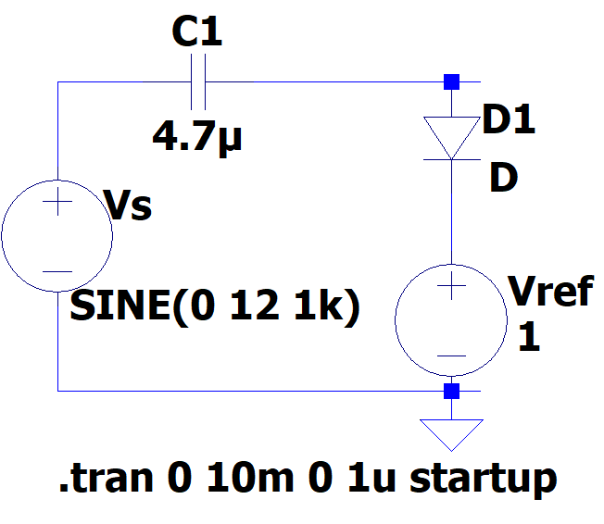

* Input Waveform:



* Input-Output Waveform:

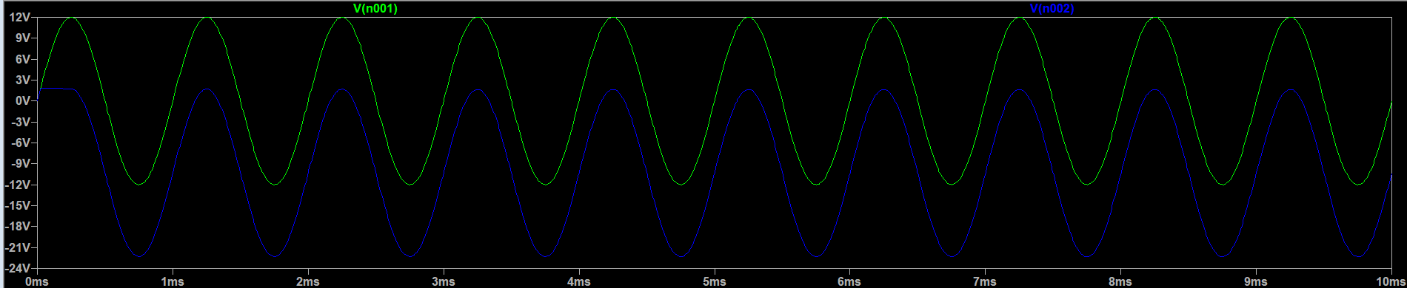

* Table Of Observations:

|  |  |  |  |  |  |  |
| --- | --- | --- | --- | --- | --- | --- |
| **SI.No** | **I/p voltage** | **Reference voltage VR in volts** | **I/p frequency** | **Positive peak voltage** | **Negative peak voltage** | **Average or DC voltage of the output** |
|  | **24** | **1** | **1k Hz** | **1.8** | **-22.2** | **-10.2** |
|  | **24** | **2** | **1k Hz** | **2.7** | **-21.2** | **-9.25** |
|  | **24** | **3** | **1k Hz** | **3.7** | **-20.2** | **-8.25** |
|  | **24** | **4** | **1k Hz** | **4.8** | **-19.2** | **-7.2** |
|  | **24** | **5** | **1k Hz** | **5.7** | **-18.2** | **-6.25** |
|  | **24** | **6** | **1k Hz** | **6.7** | **-17.2** | **-5.25** |
|  | **24** | **7** | **1k Hz** | **7.7** | **-16.2** | **-4.25** |
|  | **24** | **8** | **1k Hz** | **8.7** | **-15.3** | **-3.3** |

1. **Biased Negative Clamping Circuit With Negative Reference Volatge:**

* Circuit:

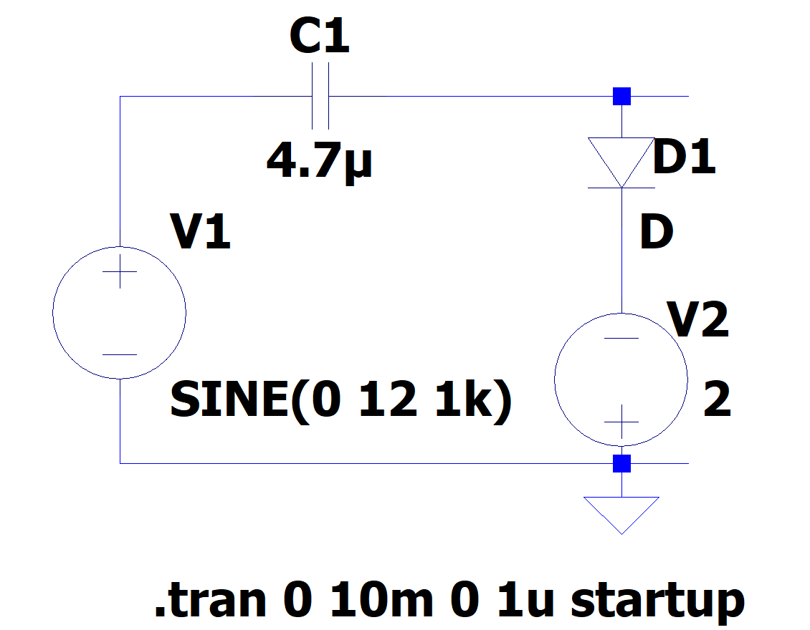

* Input Waveform:



* Input-Output Waveform:

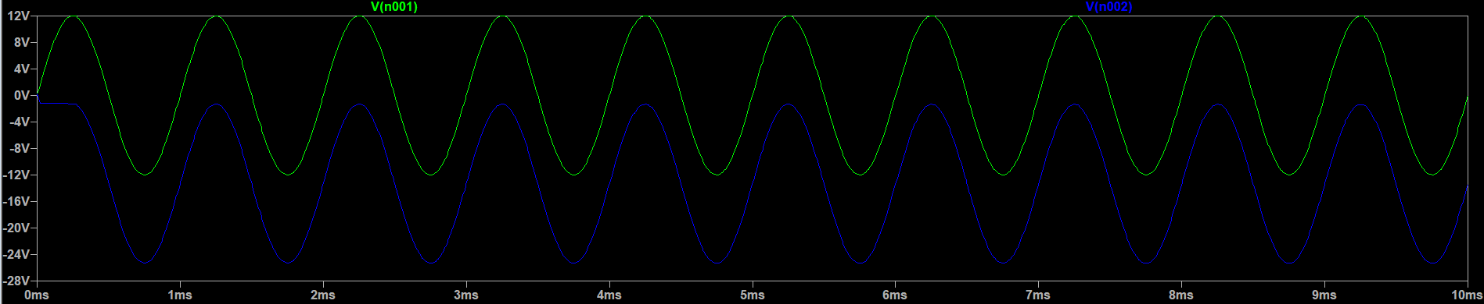

* Table Of Observations:

|  |  |  |  |  |  |  |
| --- | --- | --- | --- | --- | --- | --- |
| **SI.No** | **I/p voltage** | **Reference voltage VR in volts** | **I/p frequency** | **Positive peak voltage** | **Negative peak voltage** | **Average or DC voltage of the output** |
|  | **24** | **1** | **1k Hz** | **-0.2** | **-24.2** | **-12.2** |
|  | **24** | **2** | **1k Hz** | **-1.2** | **-25.2** | **-13.2** |
|  | **24** | **3** | **1k Hz** | **-2.2** | **-26.2** | **-14.2** |
|  | **24** | **4** | **1k Hz** | **-3.2** | **-27.2** | **-15.2** |
|  | **24** | **5** | **1k Hz** | **-4.2** | **-28.2** | **-16.2** |
|  | **24** | **6** | **1k Hz** | **-5.2** | **-29.2** | **-17.2** |
|  | **24** | **7** | **1k Hz** | **-6.2** | **-30.2** | **-18.2** |
|  | **24** | **8** | **1k Hz** | **-7.2** | **-31.2** | **-19.2** |

1. **Voltage Doubler Circuit-Half Wave Voltage Doubler:**

* Circuit:

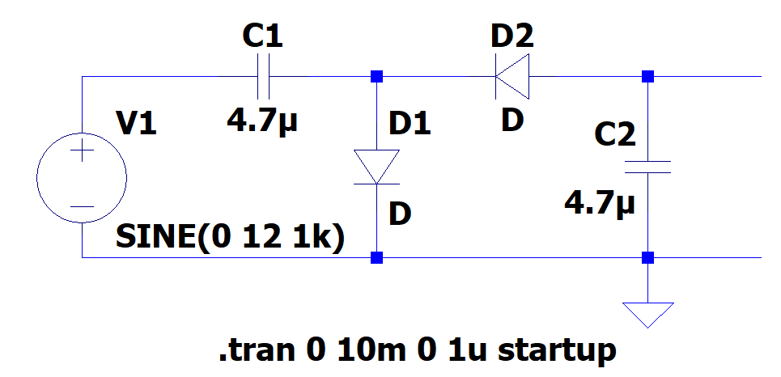

* Input Waveform:



* Input-Output Waveform:

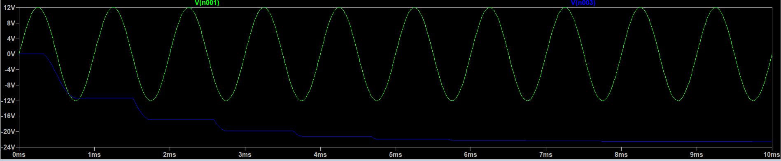

1. **Voltage Doubler Circuit- Full Wave Voltage Doubler:**

* Circuit:

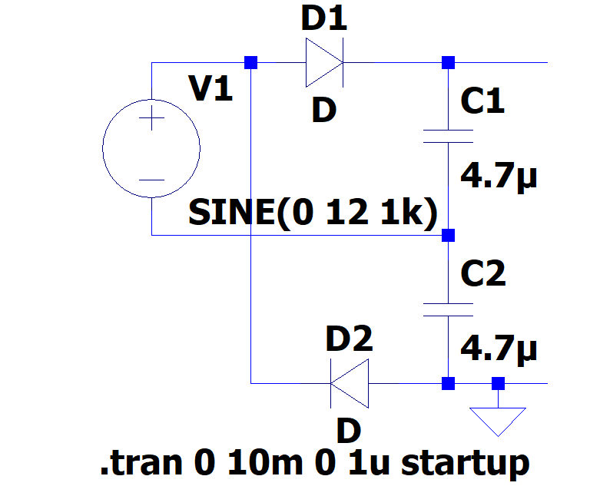

* Input Waveform:

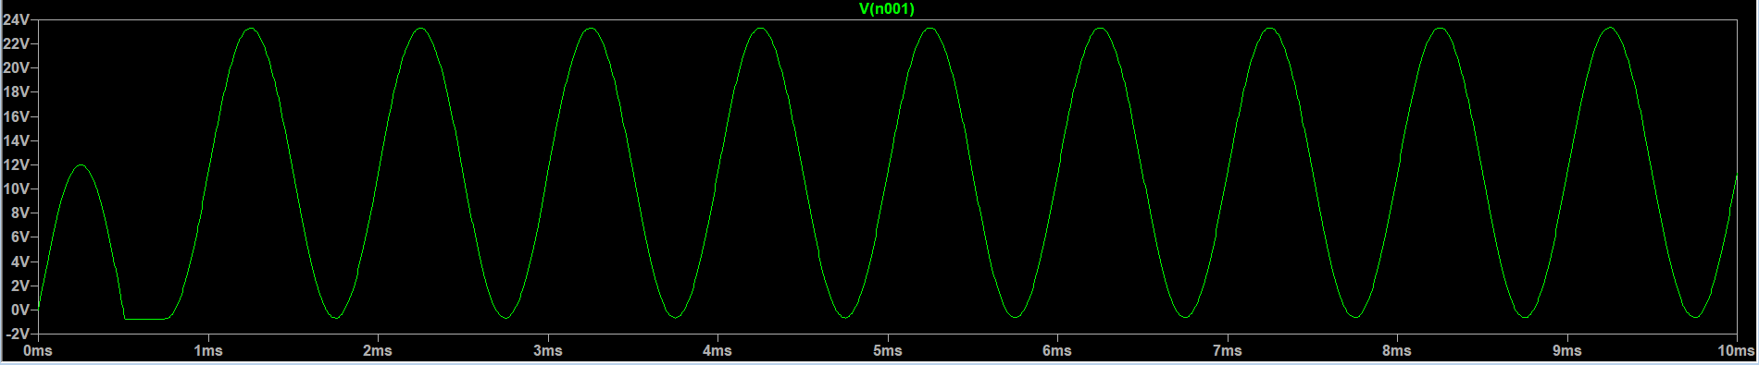

* Input-Output Waveform:

